REPORT FOR VAMAN BOARD SETUP IN TERMUX
(RUGGED PHONE)
Vemireddy Uma Gayathri

Prepare android device:
- Enable developer options

Go to settings → About phone → Find Build number

Tap in 2-3 Times and you will see “you are developer”

Enable USB Debugging

Go to setting → Developer Options

Turn on these toggles:
- USB debugging
- USB debugging (security settings)
- Connected to PC
- Plug in USB cable
- Tap “Allow USB Debugging”
- Checked always allow from this computer →tap ok

Termux installation
- Installed Termux
https://www.f-droid.org/
Downloaded Termux from F-Droid (not Play Store for full functionality)
- After installation,I gave termux access to my android storage
termux-setup-storage

- Installed ubuntu inside termux
Install ubuntu (25.10), Because ubuntu 20 and 24 were not listed in proot-distro.
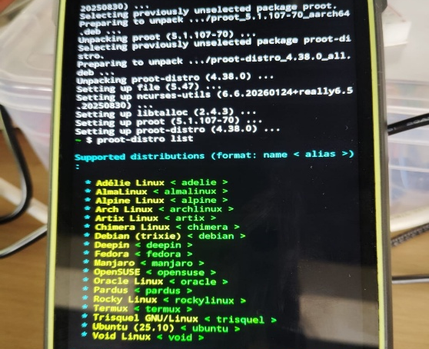
proot-distro install ubuntu (25.10 version)
- Login to ubuntu
proot-distro login ubuntu

- Then I updated and upgraded the system packages
apt update && apt upgrade
apt install build-essential
- Installed essential development tools
apt install git wget curl python3 python3-pip python3-venv -y

Setup pygmy-dev:
- Created a directory for building the toolchain
mkdir -p ~/symbiflow
export INSTALL_DIR=~/symbiflow
- Downloaded and extract symbiflow OR copy from another source
Latest: curl $(curl https://storage.googleapis.com/symbiflow-arch-defs-install/latest) > ~/arch.tar.gz

- But Get the arch.tar.gz from https://drive.google.com/file/d/17gVGRJ1qcaWanYzyg1eMUiLlFqya3_ZD to ~/arch.tar.gz

tar -C $INSTALL_DIR -xvf ~/arch.tar.gz

- Exported the file path
export PATH="$INSTALL_DIR/bin:$INSTALL_DIR/quicklogic-arch-defs/bin:$INSTALL_DIR/quicklogic-arch-defs/bin/python:$PATH"
- Cloned the Pygmy repo to local
cd ~
git clone --recursive https://github.com/optimuslogic/pygmy-dev
- Compiled yosys
cd ~/pygmy-dev/tools/quicklogic-yosys/
make config-gcc
make -j4 install PREFIX=$INSTALL_DIR
cd ~

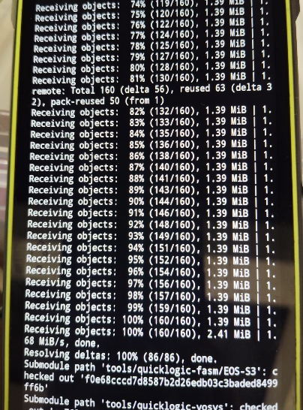

- Compiled yosys-plugins
cd ~/pygmy-dev/tools/yosys-symbiflow-plugins/
export PATH=$INSTALL_DIR/bin:$PATH
make -j4 install
cd ~
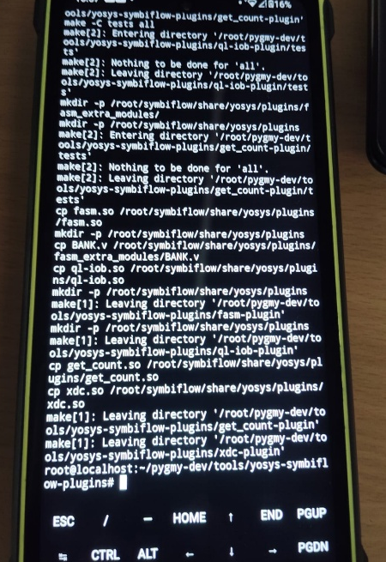

- Compile VTR
cd ~/pygmy-dev/tools/vtr-verilog-to-routing/
- Using make -j1,because make -j4 is showing that signal 9 means that android kills heavy process.
- While Installing, I faced some errors related to including header files. So I added header files(#include <limits>, #include <cstdint>)

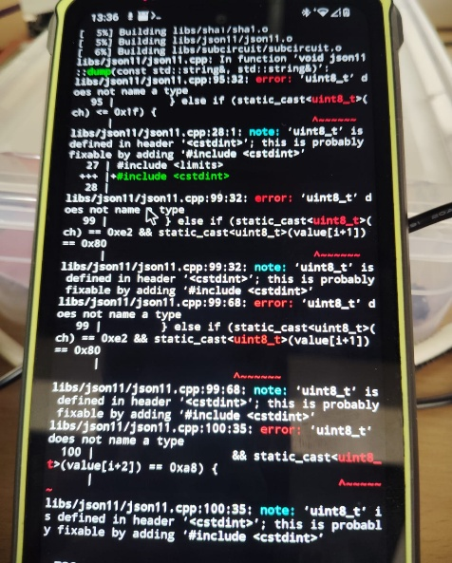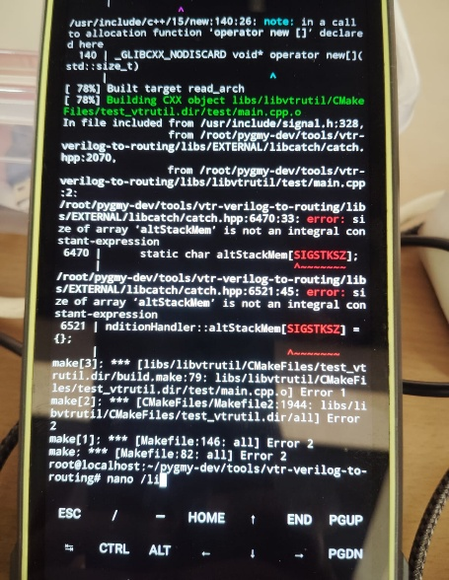

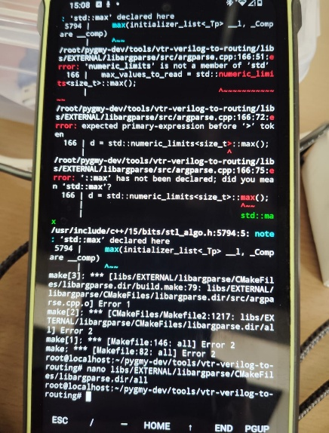

- Rebuild make -j1. It took 30 to 40 minutes to installed
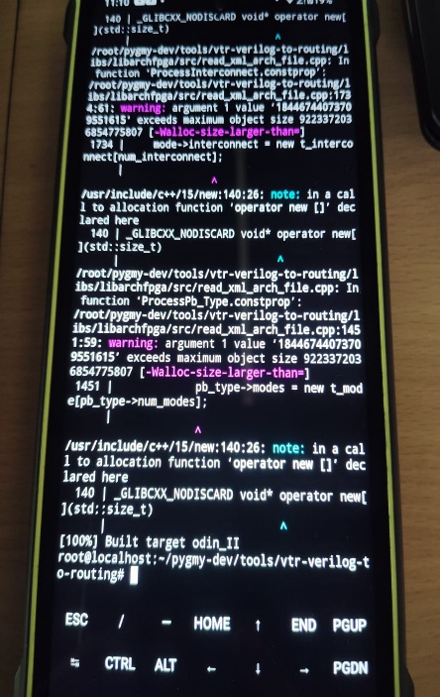
- Then changed the directory cd ~
- Copied the required binaries
cp ~/pygmy-dev/tools/vtr-verilog-to-routing/build/vpr/vpr $INSTALL_DIR/bin
cp ~/pygmy-dev/tools/vtr-verilog-to-routing/build/utils/fasm/genfasm $INSTALL_DIR/bin

- Verified the tools
vpr -h
yosys -h
genfasm -h

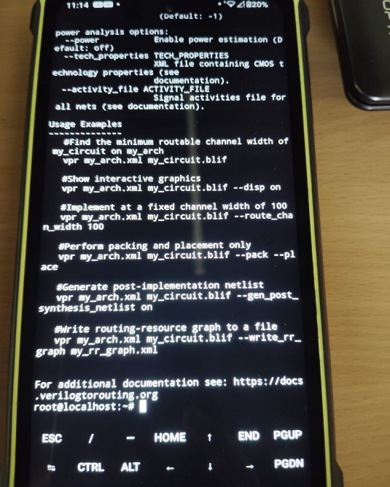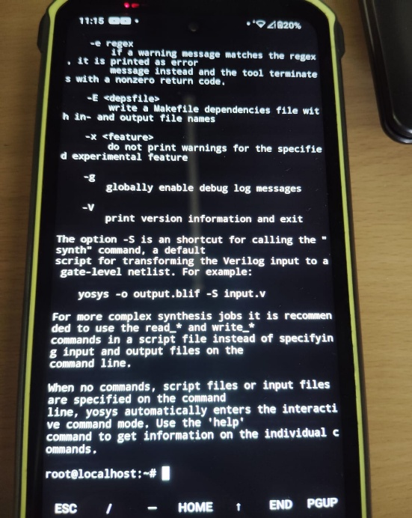

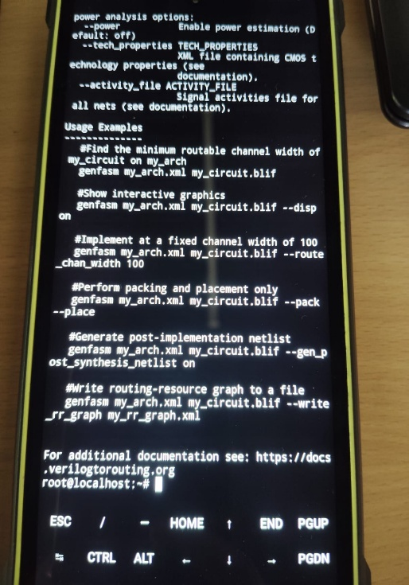

- Install pip3 and python3 setup.py
cd ~/pygmy-dev/tools/quicklogic-fasm/

pip3 install -r requirements.txt
- While installing python requirements, I encountered an error because git://links were blocked
-e git://github.com/symbiflow/fasm.git#egg=fasm
-e git://github.com/antmicro/quicklogic-fasm-utils.git#egg=fasm-utils
To
-e git+https://github.com/symbiflow/fasm.git#egg=fasm
-e git+https://github.com/antmicro/quicklogic-fasm-utils.git#egg=fasm-utils
- Then ran the python3 setup.py install
cd ~

- Checked the tools
- qlfasm -h
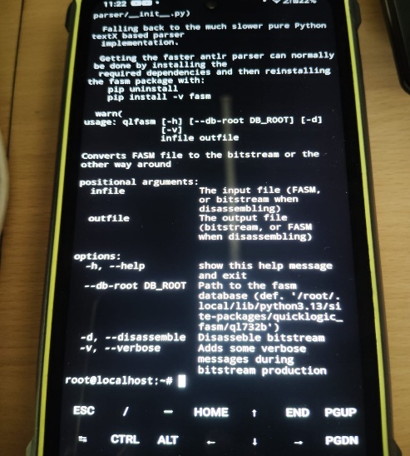

- ql_symbiflow -h -- it showed command is not found, So I tried this commands
pip3 Install gdown
gdown 17gVGRJ1qcaWanYzyg1eMUiLlFqya3_ZD -0 ~/arch.tar.gz

tar -C $INSTALL_DIR -xvf ~/arch.tar.gz

export PATH="$INSTALL_DIR/bin:$INSTALL_DIR/quicklogic-arch-defs/bin:$INSTALL_DIR/quicklogic-arch-defs/bin/python:$PATH"

Then tried ql_symbiflow -h

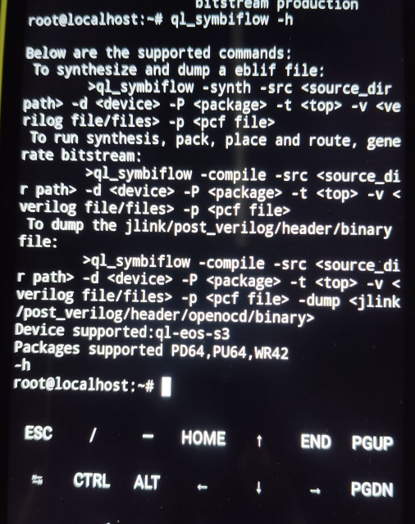

- Tested FPGA compilation which uses the tools

cd $INSTALL_DIR/quicklogic-arch-defs/tests/counter_16bit
ql_symbiflow -compile -d ql-eos-s3 -P pd64 -v counter_16bit.v -t top -p m chandalar.pcf

- Changed the directory
cd ~/pygmy-dev/pygmy-sdk/S7seg-apps/static-number/

ql_symbiflow -compile -src . -d ql-eos-s3 -t top -v seg7_static.v -p pygmy.pcf -P PU64 -dump binary

- Downloaded and extracted the ARM GCC toolchain
cd $INSTALL_DIR

wget https://developer.arm.com/-/media/Files/downloads/gnu-rm/9-2020q2/gcc-arm-none-eabi-9-2020-q2-update-aarch64-linux.tar.bz2

tar -xvjf gcc-arm-none-eabi-9-2020-q2-update-aarch64-linux.tar.bz2

export PATH=$INSTALL_DIR/gcc-arm-none-eabi-9-2020-q2 update/bin:$PATH

- Tested ARM gcc
arm-none-eabi-gcc –version

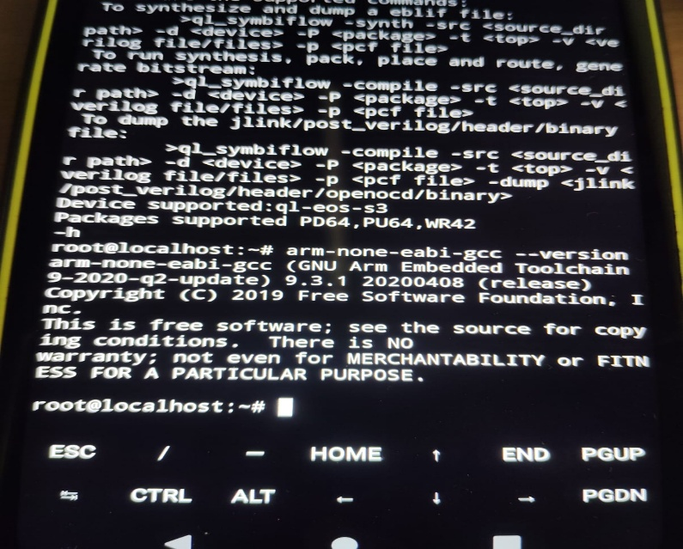

- Added the ~/.bash_profile to setup the environment variables next time

export INSTALL_DIR=~/symbiflow
export PATH="$INSTALL_DIR/bin:$INSTALL_DIR/quicklogic-arch-defs/bin:$INSTALL_DIR/quicklogic-arch-defs/bin/python:$PATH"
export PATH=$INSTALL_DIR/gcc-arm-none-eabi-9-2020-q2-update/bin:$PATH

- Tested Software & FPGA code

- cd ~/pygmy-dev/pygmy-sdk/qf_apps/qf_helloworldsw/GCC_Project/
make
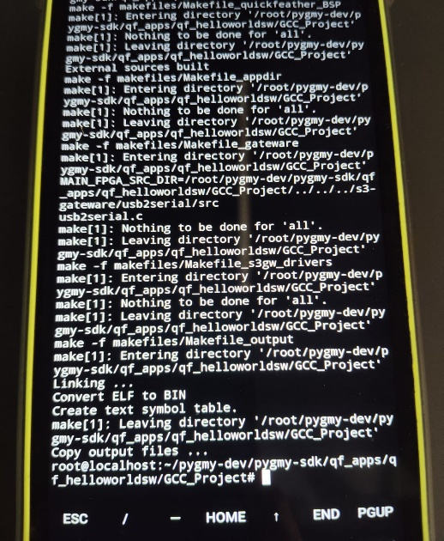

- cd ~/pygmy-dev/pygmy-sdk/qf_apps/qf_helloworldhw/GCC_Project/
make
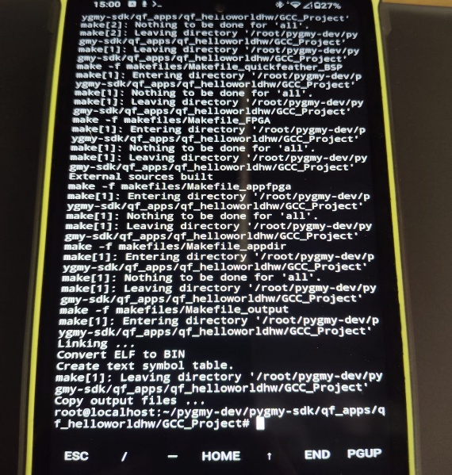

- I modified the helloworldfpga.v file and rebuild the project. The .bin file was generated successfully .
- I transferred the .bin file to my laptop and connected the vaman board. The flashing process completed successfully without errors.

- The .bin file(100kb) was generated successfully and shared to laptop (ubuntu 20 version)
- Finally the phone-generated .bin file was flashed and the LEDS blinked

